7-IN-1

Portable Air Quality Monitor
O2 | CO | AIR PRESSURE | STOPWATCH | TEMPERATURE |
RELATIVE HUMIDITY | FLASHLIGHT |
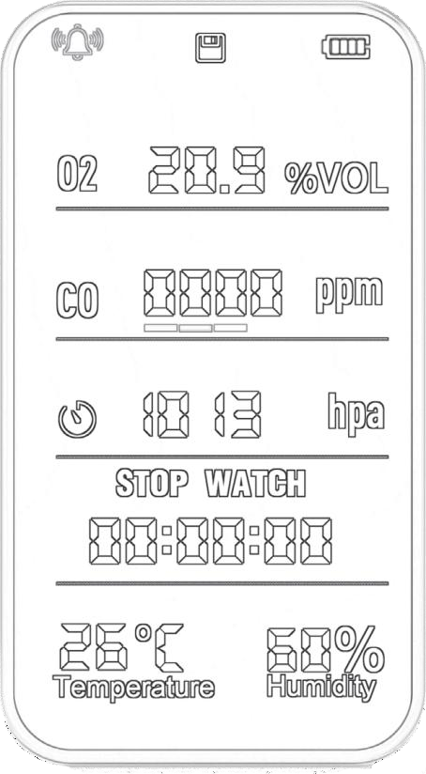

Layout

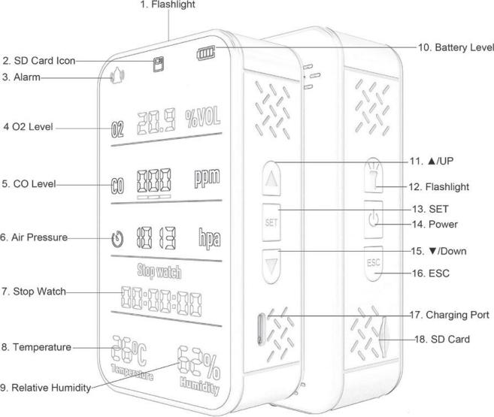
- Flashlight
- SD Card Indicator
- Alarm Indicator
- Oxygen Level
- CO Level
- Air Pressure in hPa
- Stopwatch
- Temperature (°C/°F)
- Relative Humidity
- Battery Level

Attention

- ▲/UP
- Flashlight Control
- SET Button
- Power Button
- ▼/DOWN
- ESC Button
- Type-C Charging Port
- SD Card Slot

Technical Specifications
Model Number: PT09 WIFI
CO Measurement Range: 0-500PPM
CO Measurement Accuracy: ±10ppm or ±5% Resolution: 1PPM
O2 Measurement Range: 0-30% vol O2 Measurement Accuracy: ±5% Resolution: 0.1% vol,
Atmospheric Pressure Range: 300-1100hPa Relative Accuracy: ±0.12hPa (950-1050hPa@25°C) Absolute Accuracy: ±1hPa (950-1050hPa@0- 40°C) Flashlight: 3W/160LM/8000K
Built-in Battery Capacity: 3000mAh Working Temperature: 0 °C-60 °C Working humidity: 0-95% (non-condensing) Input Voltage: DC 5V/2A
Dimension: 30*61*110mm (D*W*L） Weight: 181g

User Guide
POWER ON/OFF
Press and hold POWER button to activate/deactivate the device.

SD Card: Insert SD card (Gold Finger side upward). Single press SET to select YY/MM/DD/HR/MIN settings. Press▲/▼to input values. Press and hold SET to save setting.

OC/OF Convert
At working mode, quick press POWER button 2 times to convert temperature unit between Celsius/OCand Fahrenheit /^{O}F.
CO Alarm
When CO concentration is higher than 200 ppm, the red indicator ring starts flashing and the audio alarm beeps constantly.
When CO concentration is lower than 200 ppm, the yellow indicator ring starts flashing and the audio alarm beeps once every 10 seconds.
When Co concentration is lower than 50 ppm, the audio and visual alarms will be released automatically.
CO Alarm Threshold

CO Levels | Audio Alarm | Visual Alarm | Alarm Lift
0-50ppm | No Alarm | No Alarm | No Alarm
51-200ppm | Alarm beeps once in every 10 seconds | CO Icon and yellow indicator ring  start flashing | When alarm is lifted, CO Icon stops flashing
201-500ppm | Continuous beeping | CO Icon and red indicator ring start  flashing | When alarm is lifted, CO Icon stops flashing
Oxygen Alarm
When O2 concentration is detected lower than 19.5%, or higher than 23.5%, audio alarm starts and O2 Icon flashes at the same time.
CO/O2 Alarm Lift
When the alarm is going on, press and hold ▲ (Up Button) to temporarily stop the alarm for 5 minutes. The alarm will continue after 5 minutes if the concentration level remains higher than the threshold values.

Model: PT09
Please thoroughly read this user manual and save the document for future reference. Images used are for illustrative
purposes only.
Flashlight
Press and hold Flashlight button to turn on the flashlight, and single press to turn off.
Press and hold▼ (Down Button) to lock down visual/audio alarm. Press and hold ▼ (Down Button) again to release visual/ audio alarm.

Automatic Sleep Mode
- Sensors work once in every 20 seconds under sleep mode.
- The display will enter sleep mode after 1 minute of inactivity and save power draining.
- Press any button to return to work mode from sleep mode.
- When any parameter detects higher than the alarm threshold value, the device will turn into backlight work mode immediately.
- When the device is activated, the sensors work for once immediately and display the measurement result.
Sensor Work Frequency
CO Sensor: once in every 2 seconds O2 Sensor: once in every 10 seconds

When the device is activated, the sensors work for once immediately and display the measurement result.
Other Sensors Work Frequency
(Temperature, humidity, barometer)
Work Mode: Sensors work once in every 10 seconds.

Manual Calibration
CO calibration is only allowed for resetting “0” value due to the safety reasons.

For air pressure, temperature, and humidity, please follow the below steps:
- Hold SET to start calibration.
- Press ▼ to select another parameter.
- Press SET to enter the flashing parameter.
- Press ▲/▼ button to increase/decrease the value.
- Hold SET to save the calibrated value. Press ESC to terminate the calibration.

Automatic Calibration for Oxygen
The device provides dual automatic calibration values at 20.9% and 0%, please find the benchmark Oxygen conditions to calibrate each value.

- Hold SET to start calibration.
- Press ▼ to select Oxygen parameter.
- Press SET to enter the Oxygen calibration.
- Press ▲/▼ button to select 20.9% or 0% calibration value.
- Press SET button to automatically complete the Oxygen calibration within 20 seconds.
- Press ESC to terminate the calibration.

If any mis-operation for the Oxygen calibration process, please press ESC button for five times to reset the device and start over the Oxygen process.

Temperature
When the device is charging or held in hands, temperature measurements could be higher for 2-3oC (35.6-37.4oF).
Charging Indicators
When charging at sleep mode, the display will keep at backlight work mode.
When charging at turn off mode, the device will be activated.

Low Battery Alert
When the battery is lower than 5%, the device beeps once in every 5 minutes until it turns off automatically.
Stopwatch
- Press and hold ESC to start stopwatch mode
- Single press POWER to start/stop timing function
- Press and hold ESC to clear data and return to Home
Note: If any operational error occurs during the setup process, press the ESC key five times to restore factory settings and start over.

Package Includes:
1 x PT09 Air Quality Monitor 1 x User Manual 1 x Charging Cable 1 x Lanyard
IMPORTANT!
Do not try to modify or repair the device. All procedures, related to Service and Maintenance should be performed by professional technicians.

SAFETY INSTRUCTIONS
PT09 is not a medical device. It provides estimates intended for personal use and informational purposes only. It is subject to certain limitations and must be used in accordance with specifications and user manual. Users should review the information contained in user manual.

All the screenshots/drawings in this quick start guide are provided for explanatory purposes only. Device manufacturer has a right to update application UI/device functionality without any prior notice.

FCC COMPLIANCE STATEMENT
This equipment has been tested and found to comply with the limits for a Class B digital device, pursuant to part 15 of the FCC Rules. These limits are designed to provide reasonable protection against harmful interference in a residential installation. This equipment generates uses and can radiate in accordance with the instructions, may cause harmful interference to radio communications.

However, there is no guarantee that interference will not occur in a particular installation. If this equipment does cause harmful interference to radio or television reception, which can be determined by turning the equipment off and on, the user is encouraged to try to correct the interference by one or more of the following measures:
- Reorient or relocate the receiving antenna.
- Increase the separation between the equipment and receiver.
- Connect the equipment into an outlet on a circuit different from that to which the receiver is connected.
- Consult the dealer or an experienced radio/TV technician for help.

DECLARATION OF CONFORMITY
PT09 device is in conformity with the essential requirements and other relevant provisions of the CE, FCC, and RoHS.

Please be aware that it is your responsibility to dispose of electronic equipment at recycling centers to help conserve natural resources.

Note
This device uses electrochemical sensor technology to measure oxygen levels, and the following cases may cause oxygen level changes abnormally:
- Blow air at the device
- Suddenly increased airflow
- Sudden vibrations
The measured oxygen level will be normal after leaving the device uninterrupted for several minutes.



